Scripting Task

1. Create a shell script to print the HTTP error code of guvi.in & print, the success/failure message based on the error code response

* To create script file - **nano guvi_status.sh**
* Write the script inside it.
* Then change the script to executable – **chmod +x guvi_status.sh**
* Then run the script - **./guvi_status.sh**

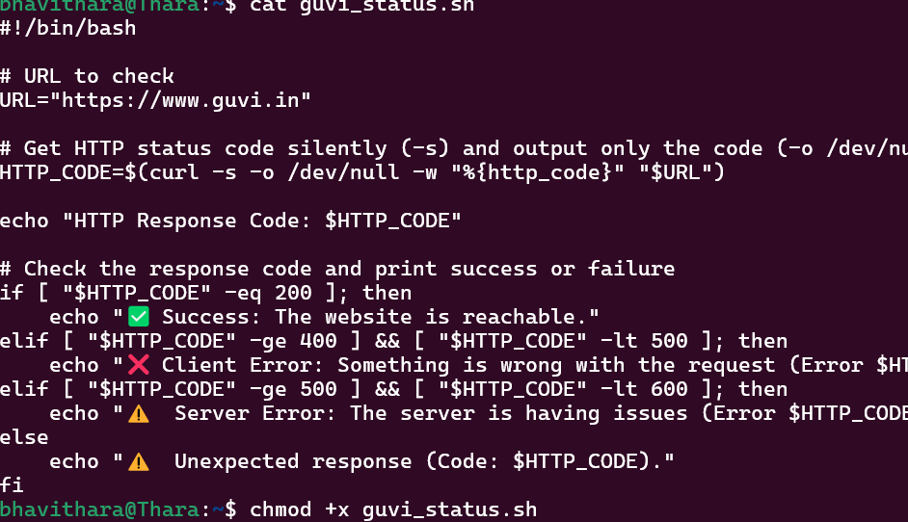

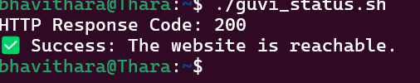

2.Given a file, replace all occurrence of the word "give" with "learning" from 5th line till the end in only those lines that contain the word "welcome"

**sed '5,$ {/welcome/ s/give/learning/g}' filename.txt**